Chapter 4, Solution 6.

Due to linearity, from the first experiment,
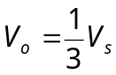

Applying this to other experiments, we obtain:

Experiment V_{s} V_{o}

2 48 16 V
3 1 V 0.333 V
4 -6 V -2V

